CSC3002 proposal of Group12 :

Innovative online UNO card game design

1.Introduction
UNO is a popular turn-based card game that combines strategy and luck, making it both entertaining and suitable for demonstrating programming concepts such as object-oriented design, data structures, and game logic. We chose this topic because it allows us to apply various key C++ skills in a fun and practical way. The project will require us to design multiple classes, manage game states, handle user inputs, and possibly implement a simple computer opponent or multiplayer mode. This project not only helps us reinforce our understanding of class inheritance, encapsulation, and polymorphism, but also gives us experience in designing a modular and interactive program.

2.Related Work
Our design ideas are inspired by the official UNO rules published by Mattel and several open-source UNO implementations available on GitHub and online programming communities. We have reviewed existing examples to understand different approaches to game logic, card management, and player turn handling.
Meanwhile, we plan to introduce original gameplay elements, such as unique character roles with special abilities, to make the game more engaging and dynamic. Our implementation will focus on clarity, scalability, and adherence to the UNO game rules, while maintaining manageable complexity for a C++ class project.

3.Our Work
The overall architecture consists of three main layers:
1.The Game Server, which acts as the central authority for game logic, room management, and player communication.
2.The Client Application, which handles the user interface, input processing, and
rendering.
3.The Database Layer, which persists player data and game history.

Followings are some detailed game rules and functions we want to implement in our project.

3.1 Basic Rule of UNO
Goal: Be the first player to get rid of all your cards.
Setup:
• Each player is dealt 7 cards.
• The remaining deck is placed face-down as the Draw Pile.
• The top card is flipped over to start the Discard Pile.
On Your Turn:
1. You may play one or more cards from your hand if you have a valid
sequence.
2. You can only play multiple cards if they all share the same number or
symbol (e.g., all 7s, all Skips).
3. The first card you play must match the color or number/symbol of the
current top card on the Discard Pile.
4. After that, you can immediately play all other cards from your hand that
have the same number or symbol as that first card.
5. If you cannot start a sequence, you must draw one card from the Draw
Pile. Your turn then ends.
Winning the Game:
• The first player to play their second-to-last card must yell "UNO!"
• If caught not saying "UNO," they must draw 2 penalty cards.
• Once a player has no cards left, they win the round.

3.2 Function cards
1. Skip Card (2 of each color)
· Function: The next player in the sequence loses their turn
· Rules: Can be played on a card of the same color or on another Skip card of any color.
2. Reverse Card (2 of each color)
· Function: Reverses the direction of play.
· Gameplay Rules: Can be played on a card of the same color or on another Reverse card of any color.
3. Draw Two Card (2 of each color)
· Function: The next player must draw two cards from the draw pile and lose their turn.
· Gameplay Rules: Can be played on a card of the same color or on another DrawTwo card of any color.
4. Wild Card (2 cards)
· Function: The player who plays this card gets to choose the color that continues play.
5. Wild Draw Four Card (2 cards)
· Function: The player gets to choose the new color, and the next player must draw four cards and lose their turn.
· Gameplay Rules: This card can only be played if the player does not have a card in their hand that matches the current color
6. Package Card (2 of each color)
· Function: When played, the player may discard ALL cards of one color (exclude function cards) from their hand simultaneously.
· Gameplay Rules: Can only be played on a matching color or on another Package card.
7. Flash Card (2 cards)
· Function: When played, the player chooses a color. Other players must then play cards of that color in sequence. Any player unable to play a card of the specified color must draw cards equal to the number of that colored card already played by previous players during this effect.

3.3 Character System
This project designs an innovative character system for the UNO card game, introducing five unique game characters while preserving the core gameplay of traditional UNO. Each player is randomly assigned a character identity at the start of the game, enhancing strategic depth and entertainment value through the use of distinctive character skills.

Detailed Character Introduction
- Lucky Star
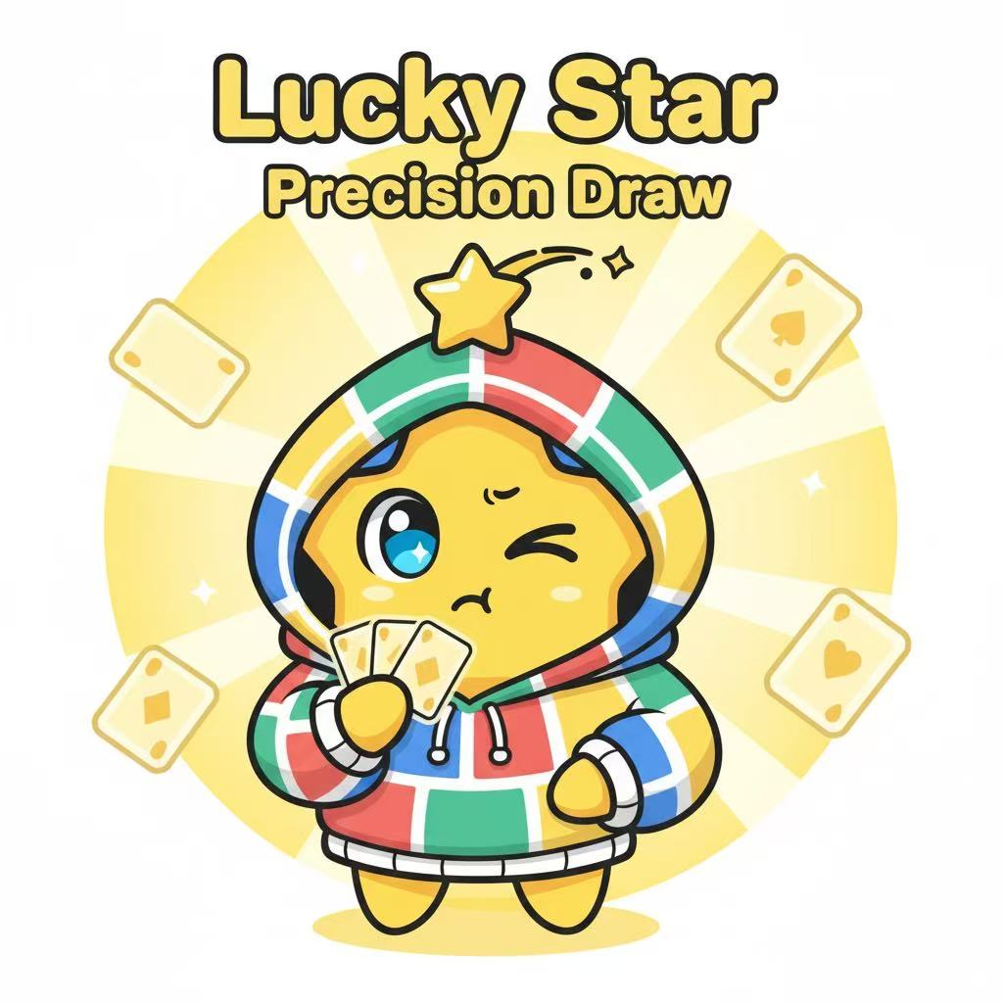
Skill Mechanism:
- Activated during any card-drawing phase
- View the top three cards of the deck and select
one to add to your hand
- The remaining two cards are returned to the top
of the deck in their original order
- After using the skill, the original deck sequence
is visible only to the Lucky Star player
Usage Restrictions:
- Can be used up to 3 times per round
- Enters cooldown after each use, making it unavailable in the next round
- Becomes permanently unavailable for the remainder of the game after reaching the 3-use limit
2. Collector
Skill Mechanism:
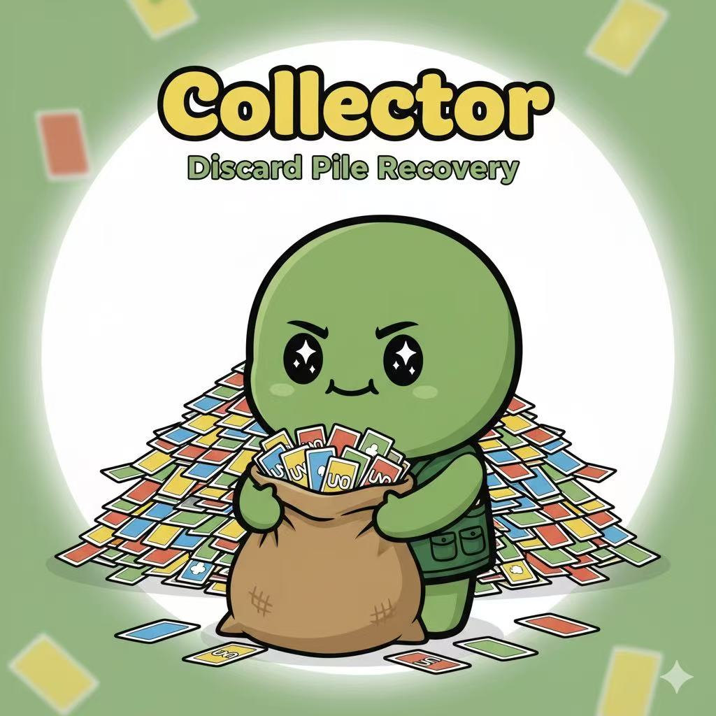
- Used during the player's own turn, before the
card-playing phase
- View all cards in the current discard pile
- Select one card to add to your hand
- The chosen card must be publicly revealed
to all players
- The discard pile maintains its original order
Usage Restrictions:
- Can be used only once per round
- Enters cooldown after use, making it unavailable in the next round
- Cannot select cards that were just discarded in the same turn
3. Thief
Skill Mechanism：
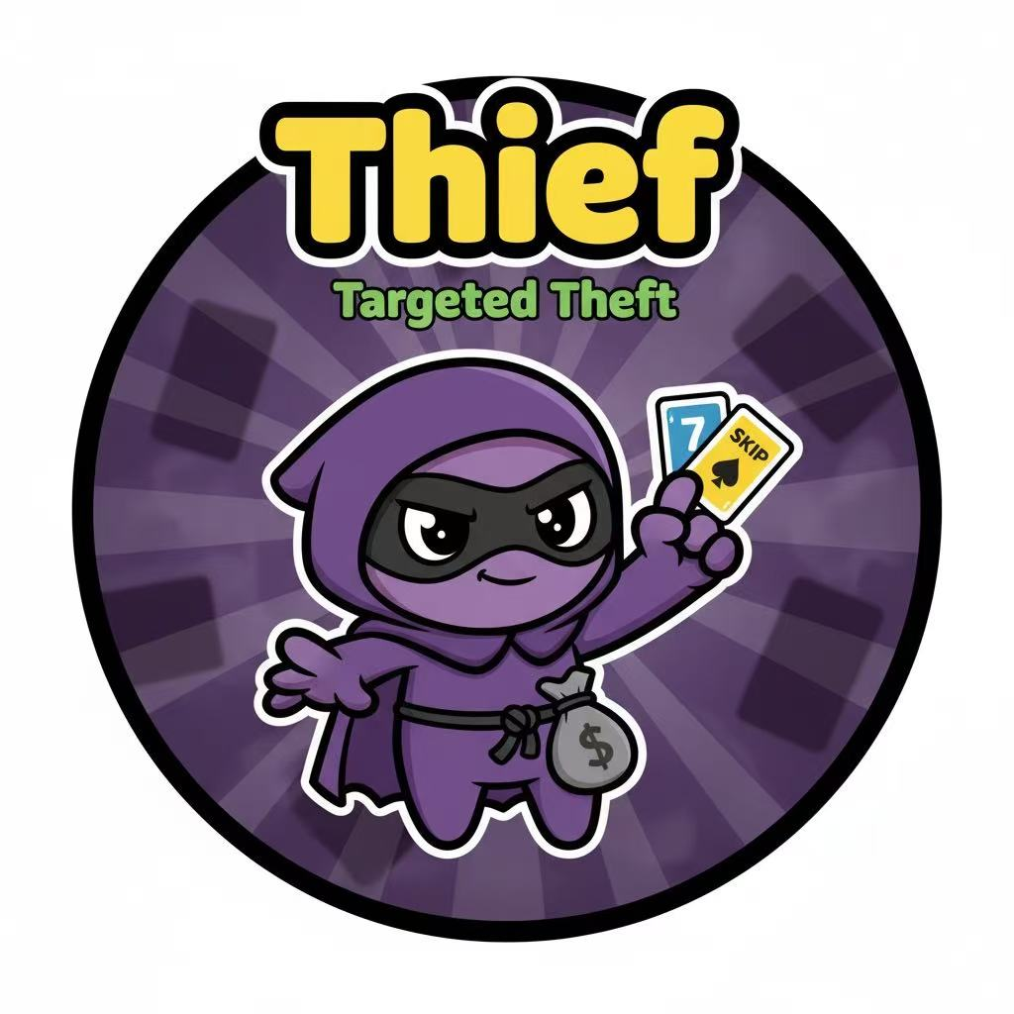
- Used during the player's own turn, before the
card-playing phase
- Select another player as the target and specify
the card type to steal: action cards or number cards
- If the target player has the specified card type,
randomly steal one card while simultaneously returning
one card from your hand to the target player
- The stolen and returned cards can be of different types
Usage Restrictions:
- Can be used only once per round
- If the target player lacks the specified card type, the skill fails and enters cooldown
- Cannot be used again in the next round, regardless of success or failure
4. Defender
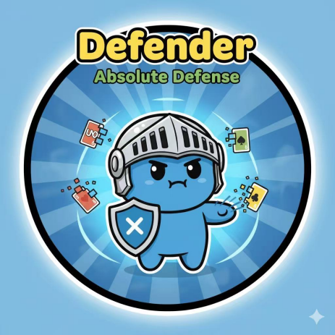
Skill Mechanism:
- A passive skill that triggers automatically
without active use
- Automatically activates when another player
uses a character skill against the Defender
- Upon successful defense, the Defender's character identity is immediately revealed
- The original skill user is still considered to have used the skill and enters cooldown
Usage Restrictions:
- Can only defend against one skill effect per round
- Enters cooldown after successful defense, making it unavailable in the next round
- Cannot defend against inherent game rule effects (such as +2, +4 card effects)
- Cannot defend against non-targeted global skill effects .

Turn Procedure:
1. Turn Start Phase: Available skills are highlighted
2. Skill Usage Phase: Players choose whether to use skills
3. Card Playing Phase: Traditional UNO card-playing process
4. Turn End Phase: Skill cooldown status is updated

The highlights of our project are:
1.The Character System: This is our core innovation. We will implement multiple characters, each with a unique active or passive skill, introducing deep strategic layers and player asymmetry not found in traditional UNO.
2.More Function Card: We will implement our newly designed "Package Card" and "Flash Card" , which create more dynamic and unpredictable gameplay.

4. Schedule
1. Project Planning and Design
Description: Finalize the game design for the innovative UNO version, including new rules, special card functions, system architecture, and unique features. Create a detailed project plan with task assignments and timelines.
Estimated completion date: 2025.10.13
2. Game Core Logic and Card System Implementation
Description: Develop the fundamental game flow, including dealing, playing cards, and the logic for standard UNO actions (skip, reverse, draw). Implement both standard and your newly designed innovative cards.
Estimated completion date: 2025.10.31
3. Multiplayer Game Mode and Network Features
Description: Implement the online multiplayer mode, managing player turns, synchronizing card effects, and handling the basic network communication required for gameplay.
Estimated completion date: 2025.11.20
4. Graphical User Interface (GUI)
Description: Design and create the user interface, including the main game board, card displays, player information, and game status indicators, focusing on a user-friendly and visually appealing layout.
Estimated completion date: 2025.12.06
5. Testing and Debugging
Description: Conduct comprehensive testing to identify and resolve bugs. Ensure the game flow is smooth and all features are stable and functional.
Estimated completion date: 2025.12.10
6. Project Report
Description: Write a detailed project report summarizing the project's objectives, development process, technical implementation, and key innovations.
Estimated completion date: 2025.12.12
7. Final Adjustments and Submission
Description: Perform final polishing of the game, optimize the user experience, and prepare the project for final demonstration and code submission.
Estimated completion date: 2025.12.13

5. Team
Game Logic Developer
Name: 萧思浩 吴宇皓
Student ID: 1155235366 124090693
Responsibilities: Responsible for implementing the core game rules, including the card matching logic (color, number), the turn-based system, and handling all special card effects (e.g., Skip, Reverse, Draw Two, Wild, and any custom innovative cards). This role also manages the overall game flow, such as drawing from the deck and determining the winner.
Graphics/GUI Developer
Name: 石曉悠
Student ID: 1155234918
Responsibilities: In charge of designing and developing the graphical user interface (GUI). This includes rendering the main game board, displaying player hands, managing the card piles (draw and discard piles), and creating visual effects or animations for card plays to ensure an intuitive and engaging user experience.
Multiplayer Developer
Name: 郭明嘉
Student ID: 124090155
Responsibilities: Focuses on implementing the multiplayer features. This includes managing network connections between players, synchronizing the game state (e.g., the current card in play, number of cards in each player's hand), and ensuring all player actions are transmitted and received accurately in real time.
Backend / Systems Developer
Name: 陈享晴
Student ID: 1155227178
Responsibilities: Handles the game's backend systems and overall architecture. Responsibilities include managing the card deck (shuffling, dealing), handling game state transitions (starting a new game, ending a turn), and implementing features like saving/loading game progress or tracking player scores, ensuring the game runs stably.
Tester and Debugger
Name: All team members
Responsibilities: Conducts comprehensive testing across all aspects of the game. All members are collectively responsible for identifying and reporting bugs related to game mechanics, multiplayer synchronization, and the graphical interface. This role also involves collaborative debugging and making final adjustments to ensure a stable and polished gameplay experience.

